Instructions to generate the Usage Metrics Report

- Log-in to SAP
- Open transaction /N/INVMWL/KPI
- After you run this transaction, you will get the selection criteria (first screen). In the selection criteria, you can do a wide open search or select Purchase Order, Sales Quotation etc. to see specific document types.
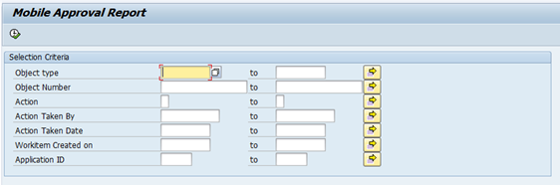

- After entering the search criteria, execute the report and you will see a report that shows all the records containing users who have been approving/rejecting, documents that are being approved/rejected and date stamp of the action.

