Some networks require you to use a proxy server to access the Internet. A proxy server is another computer or device that acts as an intermediary between you and the Internet by relaying your requests to a server and the servers responses back to you. Unfortunately, this type of setup requires you to specify certain settings in order for you to use the Internet properly. This section will provide information on how to configure your iPad\iPhone to use a proxy server.
Step 1. Start the iPad.
Step 2. Tap on the Settings app. When the Settings app loads, you will be at the General Settings category.
Step 3. Tap on the Wi-Fi settings category and you will be at a screen as shown below.
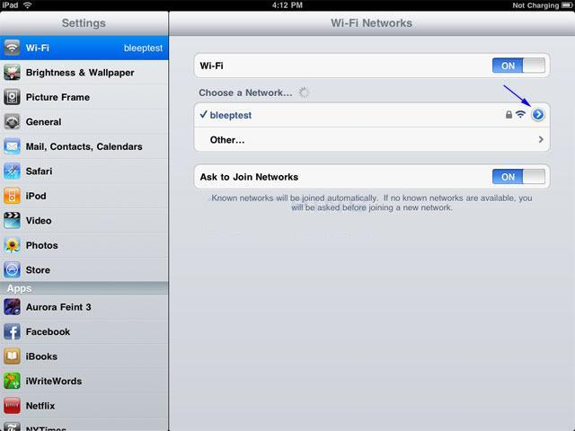
Screen showing the iPad connected to a wireless network
You should now tap on the "icon" to access the specific settings of the wireless connection.
Step 4. You will now be at the Wi-Fi network settings screen for the connected network.
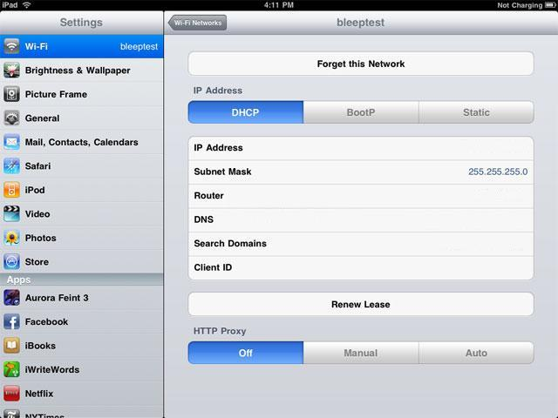
Wireless settings for a Wi-Fi network
Step 5. Tap on the Manual button and fill in the fields under HTTP Proxy. My Details
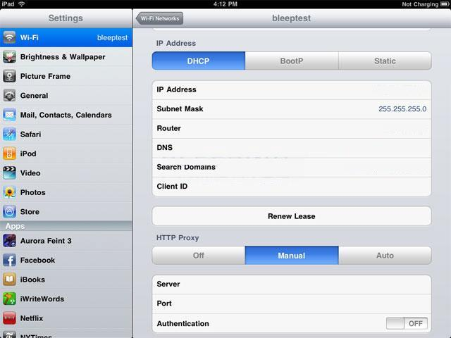
Screen showing the iPad connected to a wireless network
Make sure you slide Authentication to ON and input your login credentials. Default Port is: port 9339
Step 6. When you are done setting up your proxy server, tap on the Wi-Fi Networks button and then go back to your Home screen to start using the iPad with these new settings.

