Apple Distribution Certificates,App ID, Push Certificates

Overview of Steps

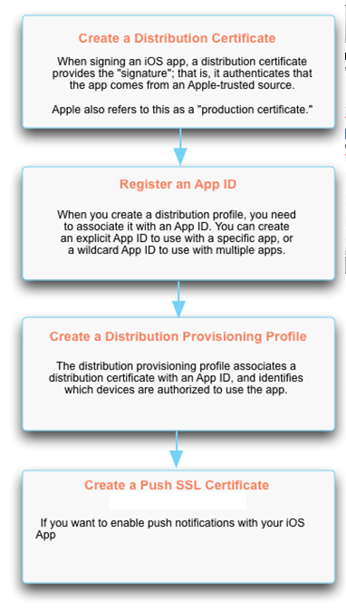

General Requirements
Before performing any of the procedures on this page, check that you meet these requirements
- Have a computer running Mac OS X 10.7 or higher. You cannot sign the iOS App on a computer running Microsoft Windows.
- Have an Apple Developer account. Enroll in the iOS Enterprise Developer program (if you have not already). When you enroll, you are given an Apple Developer account that provides access to everything you need to develop and distribute apps for iOS. To enroll, go to iOS Developer Program.
You can register for the iOS Enterprise Developer Program. An Enterprise account supports "Enterprise Distribution" to an unlimited number of devices..

- Have a Team Agent or Team Admin role for the Apple Developer account. To access the iOS Developer Library, you must sign in using the Apple ID and password for your Apple Developer account.

Create a Distribution Certificate

To create a distribution certificate:
Note: If you already created no need to create again we can use this certificate for all the apps.
- Generate a Certificate Request
Go to Keychain Access - Choose Keychain Access -> Certificate Assistant -> Request a Certificate from a Certificate Authority.
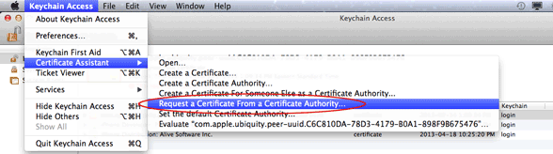

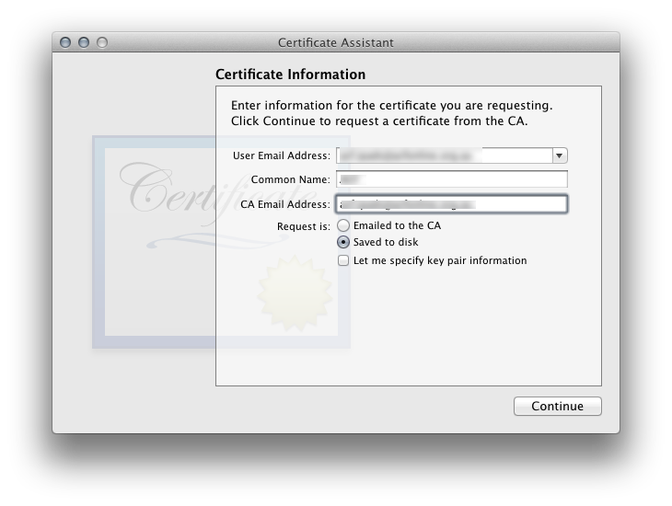

- Enter the required information.
Email Address:
Common Name:
CA Email Address
Select the options "saved to disk" and click Continue. Specify a filename and click Save to save the file CertificateSigningRequest.certSigningRequest to your desktop.
Note: Email Address and CA Email address are same or else you can leave CA email address as empty

- Log in to the iOS Dev Center with the Apple ID and password for your Apple Developer account. Note that you must have a Team Agent or Team Admin role to create a distribution certificate.
- Under iOS Developer Enterprise Program in the right panel of the page, click Certificates, Identifiers & Profiles.
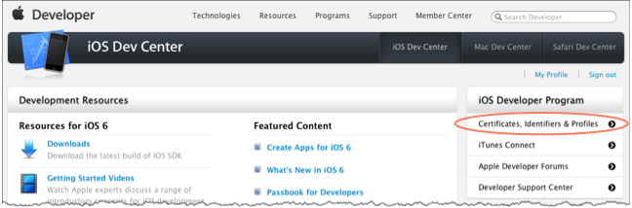
- On the left menu, click Certificates.
- Click the Production tab.
Previously, the Production tab was called "Distribution." Throughout most of its documentation, Apple still uses the term "distribution certificate." "Distribution certificate" and "production certificate" are synonymous.

- Click the Add (+) button to display Add iOS Certificate page where you can select the type of certificate you need.
- Under Production, select In House and then click Continue.
- 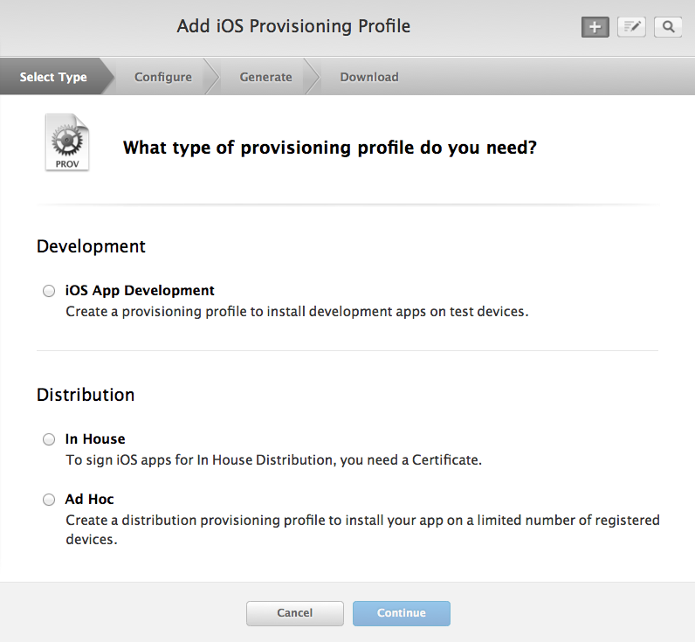
This displays a procedure for creating a Certificate Signing Request (CSR).
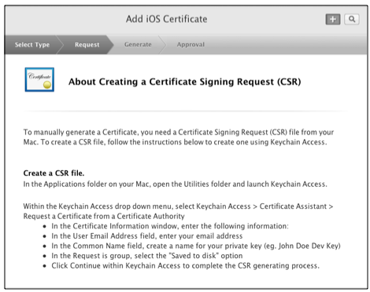
- We already created refer step 1.
- Under Upload CSR file, click Choose File and browse to select the CSR file you saved to your desktop.
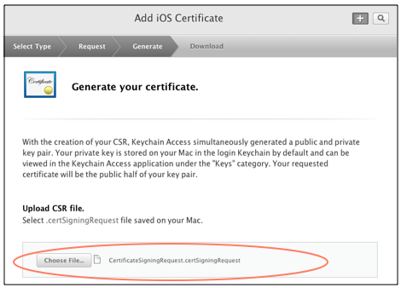
- After the CSR is uploaded, click Generate.
- When the certificate is ready, click Done.
- In the list, click on the certificate to display details about the certificate.
- Click Download to save the file to your Downloads folder.
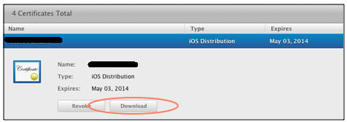
- Continue with the next procedure to add the certificate to your Keychain.

Add a Distribution Certificate to Your Keychain
- Double-click on the certificate you saved to your Downloads folder when you created a distribution certificate. This adds the certificate and its associated private key to your Login Keychain.
- To verify that the certificate was added properly, open the Keychain Access application and view items in the Login Keychain. You should see a certificate named "iPhone Distribution: Name." If you click the arrow to the left of the certificate, you will see the private key associated with the certificate.
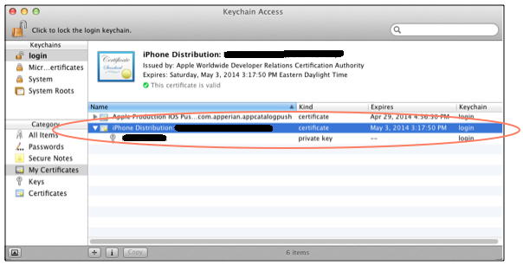

If you do not see the certificate in your Login Keychain, check to see if it is in a different Keychain. If it is, move it to your Login Keychain.

Export a Distribution Certificate to a PKCS #12 File
If using a distribution certificate with the EASE signing server, you need to upload the certificate file in PKCS (Personal Information Exchange) #12 format. The file must have a .p12 extension.

To export a distribution certificate from your Login keychain to a .p12 file:
- On your Mac, open Keychain Access.
- In the My Certificates category of your Login Keychain, highlight both the iPhone Distribution certificate and its private key and right-click. Then choose Export 2 items.
- In the Save As field, enter a name for the certificate file.
- From the Where list, select a location to save the file.
- From the File Format list, select Personal Information Exchange (.p12).
- Click Save.
You will be prompted to enter a password for the certificate file.
- (Optional) In the Password and Verify fields, enter a password for the certificate file and click OK. You will be prompted for this password when you save iOS signing credentials in EASE or sign an app using one-time credentials. If you do not want to assign a password to the file, leave these fields blank. Innovapptive recommends that you do assign a password.
- When prompted, enter your Login Keychain password to authorize Keychain Access to export the items. Click Allow.

Creating an App ID
- Log in to the iOS Dev Center with the Apple ID and password for your Apple Developer account.
- Under iOS Developer Program in the right panel of the page, click Certificates, Identifiers & Profiles.
- Under the iOS Apps section, click Identifiers.
- Click the Add (+) button.
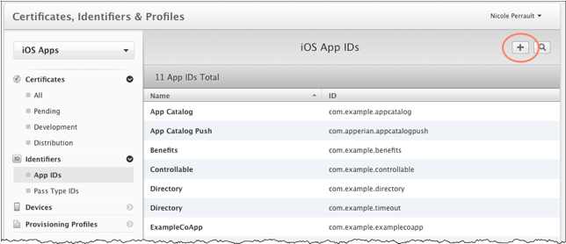
- In the App ID Description field on the Register iOS App ID page, enter a description for the app (for example: Actions). This name is used by the provisioning portal to identify the App ID

- Under App ID Prefix, the bundle seed ID is automatically created for you using your Team ID.

- Under App ID Suffix, specify the Bundle ID according to the following instructions.
If... | Then...
You want to use the App ID to associate a provisioning profile with a single app.(Recommended) | Select Explicit App ID and then enter a unique string in the Bundle ID field. Apple recommends using a reverse-domain name style string in the format of reversedomain.appname (for example:com.example.actions). The string cannot contain an asterisk (*).  If you are creating an App ID for an App or any other app that will receive push notifications, you must select Explicit App ID. Push notifications will not work with an app signed with a provisioning profile that is associated with a wildcard App ID.  Be sure to enter a unique suffix for each explicit App ID. If you are creating App IDs for multiple App, for example, use different application names for each App. For example: com.innovapptive.appname
You want to use the App ID to associate a provisioning profile with multiple apps. | Select Wildcard App ID and then enter * (asterisk) in the Bundle ID field.  Enter only * (asterisk) in the field; do not enter domain.*. If you enter domain.* (for example:com.example.*) you will receive an error when you try to upload the signed IPA file to EASE.
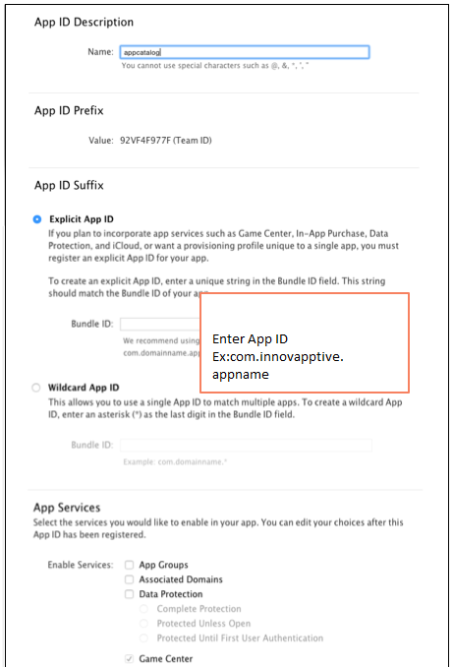

- Under App Services, select the services you would like to enable in your app. you should select Push Notifications if you want to enable the App for push notifications. Note that you can edit your choices after the App ID has been registered.
- Click Continue.
- If all the selections are correct on the Confirm your App ID page, click Submit to complete the registration.
- Click Done to return to the list of App IDs. You will see the new ID in the list.
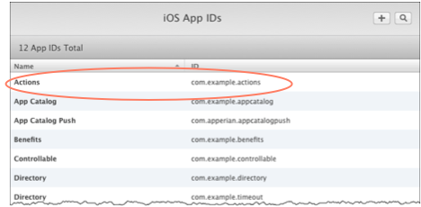

Create a Distribution Provisioning Profile
- Log in to the iOS Dev Center with the Apple ID and password for your Apple Developer account.
- Under iOS Developer Program in the right panel of the page, click Certificates, Identifiers & Profiles.
- Under the iOS Apps section, click Provisioning Profiles.
- Under Provisioning Profiles, click Distribution to display the iOS Provisioning Profiles (Distribution) page.
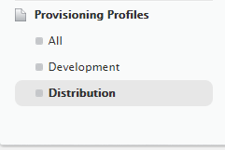
- Click the Add (+) button to display the Add iOS Provisioning Profile page where you can select the type of profile you need.
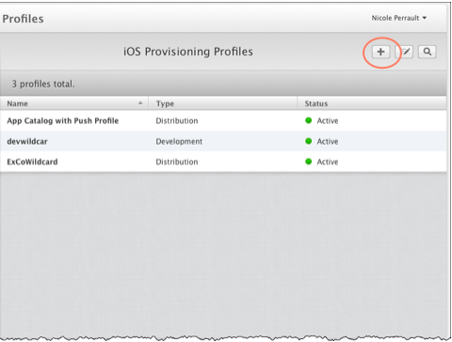
- If you are registered for the iOS Developer Enterprise Program, choose In House as the distribution method.
- Click Continue.
- On the Select App ID page, select the App ID and then click Continue. You can select an explicit App ID if you want to use the profile with a specific app, or you can select a wildcard App ID if you want to use the profile with any iOS app.
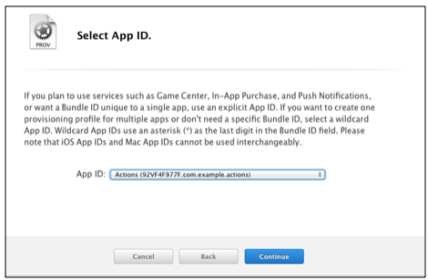
- On the Select certifications page, select a certificate and then click Continue.
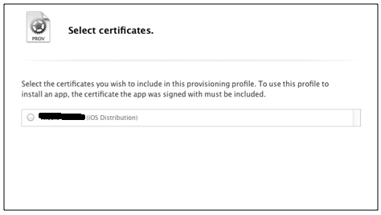
- On the Name this profile and generate page, enter a name in the Profile Name field. This is the name that will be used to identify the profile in the portal.
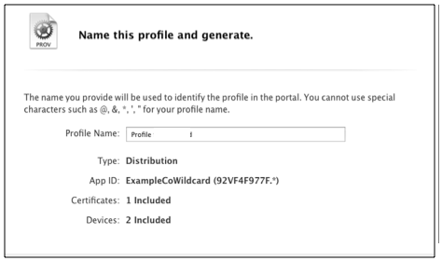
- Click Generate to create the profile.
- When the page indicates that "Your provisioning profile is ready," click Download to download profilename.mobileprovision file to your Downloads folder.
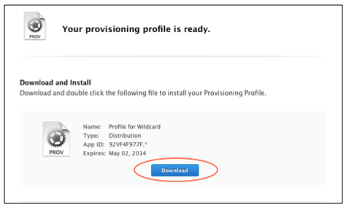
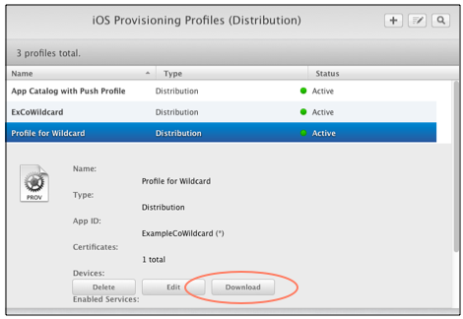

Create a Push SSL Certificate

To create a push SSL certificate:
- Log in to the iOS Dev Center with the Apple ID and password for your Apple Developer account.
- Under iOS Developer Program in the right panel of the page, click Certificates, Identifiers & Profiles.
- Under the iOS Apps section, click Identifiers->App IDs.
- Click Edit at the bottom of the page.
- On the iOS App ID Settings page, ensure that Push Notifications (towards the bottom of the page) is enabled.
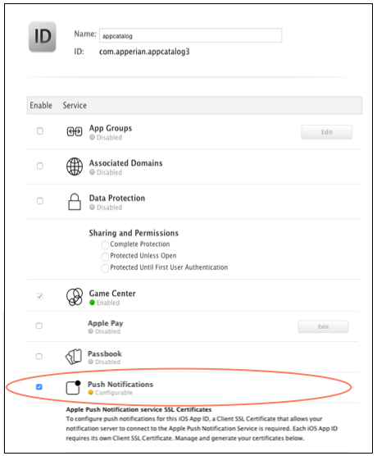
- Under Push Notifications, in the Production SSL Certificate section, click Create Certificate to display instructions for generating a Certificate Signing Request (CSR).

- Follow the instructions to generate a CSR and save it to your desktop.
Generate a Certificate Request
Go to Keychain Access - Choose Keychain Access -> Certificate Assistant -> Request a Certificate from a Certificate Authority.

Enter the required information.
Email Address:
Common Name:
CA Email Address
Select the options "saved to disk" and click Continue. Specify a filename and click Save to save the file CertificateSigningRequest.certSigningRequest to your desktop
Note: Email Address and CA Email address are same or else you can leave CA email address as empty
- Click Continue.
- Click Choose File to select the CSR that you just saved to your desktop and then click Generate.
- When the page indicates that "Your certificate is ready," click Download to save the Certificate (.cer) file to your Downloads folder.
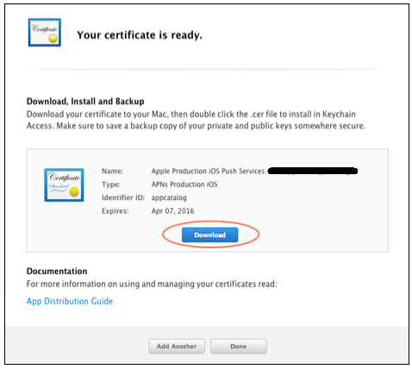
You are now ready to add the certificate to your Keychain.

Add a Push SSL Certificate to Your Keychain

Double-click on the aps_production.cer file you saved to your Downloads folder when you created the push SSL certificate. This automatically installs the certificate in your Login Keychain and opens the Keychain Access application.
In the Keychain Access window, you should see the Apple Production iOS Push Services certificate. If you click the arrow to the left of the certificate, you will see the private key associated with the certificate.
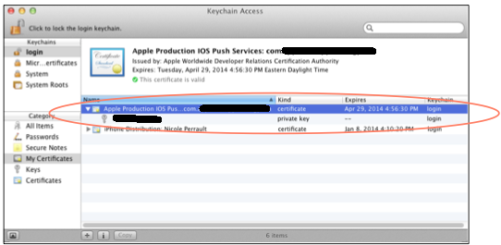

Export a Push SSL Certificate to a PKCS #12 File

To export a push SSL certificate from your Login keychain to a .p12 file:
- On your Mac, open Keychain Access.
- In the My Certificates category of your Login Keychain, highlight both the Apple Production iOS Push Services certificate and its private key, right-click them and then choose Export 2 items.
- In the Save As field, enter a name for the certificate file.
- From the Where list, select a location to save the file.
- From the File Format list, select Personal Information Exchange (.p12).
- Click Save.
- You will be prompted to enter a password for the certificate file. Leave the password fields blank and click OK.
- When prompted, enter your Login Keychain password to authorize Keychain Access to export the items. Click Allow.

