Contents
1. HCPMS 3
1.1 View Logs on HCPMS 3
2. HANA Cloud Connector 7
2.1 View Logs on HANA Cloud Connector 7
3. Device Logs 9
3.1 View Logs on Android Device 9
3.2 View Logs on IOS Device 11
4. Error Logs in Backend 13

HCPMS

View Logs on HCPMS

Login to HCP, and access HCPms Service to access mobile applications configured on HCPms.
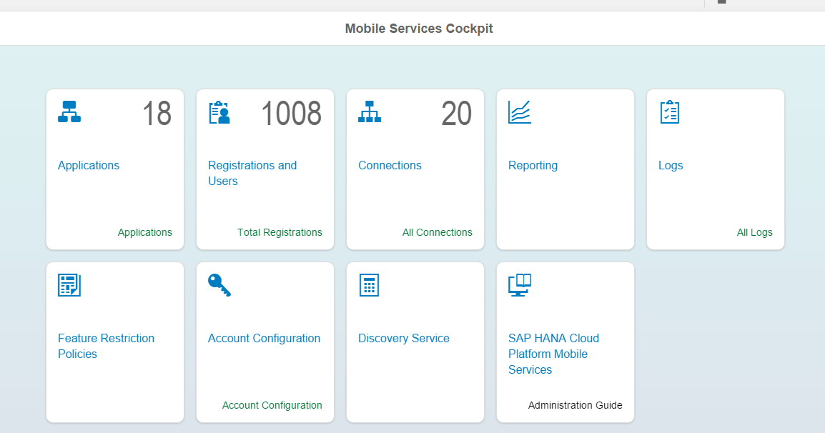

Registrations tab provides information on the users logged into mobile application, as there will be a unique registration ID generated for every successful login of user.

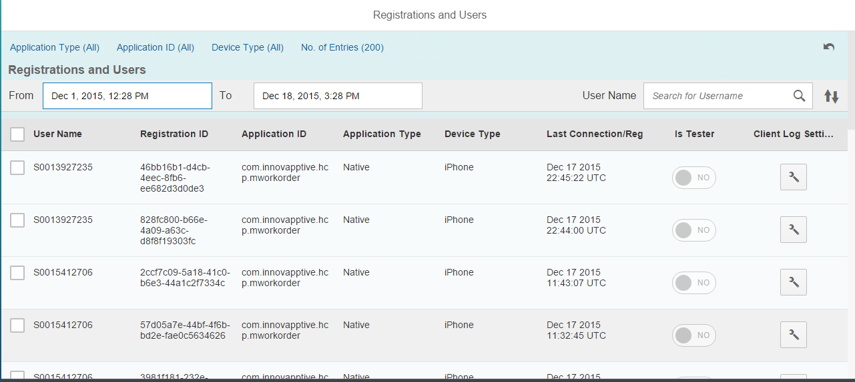
Navigate to ‘Logs’ tab to access all the logging information for the users and applications.
Click on ‘Client log Settings’ to filter the logs information based on the Client Log Settings applied.
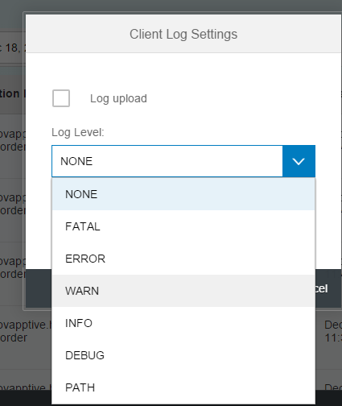
We can also filter the logs based on the timestamp selected in Logs View.
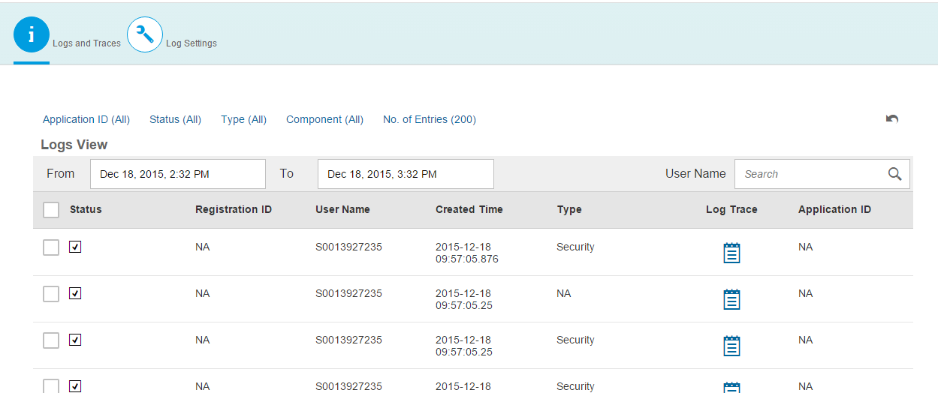
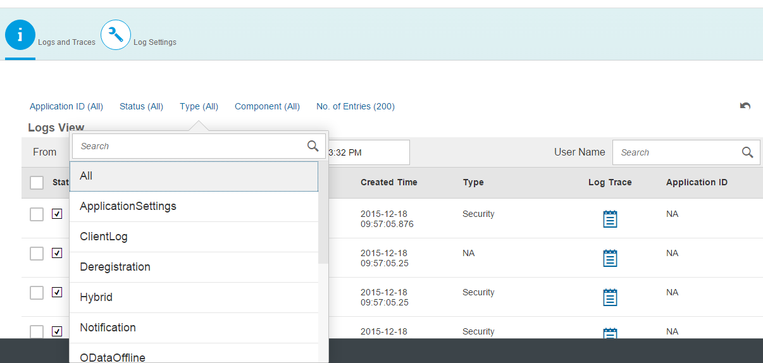

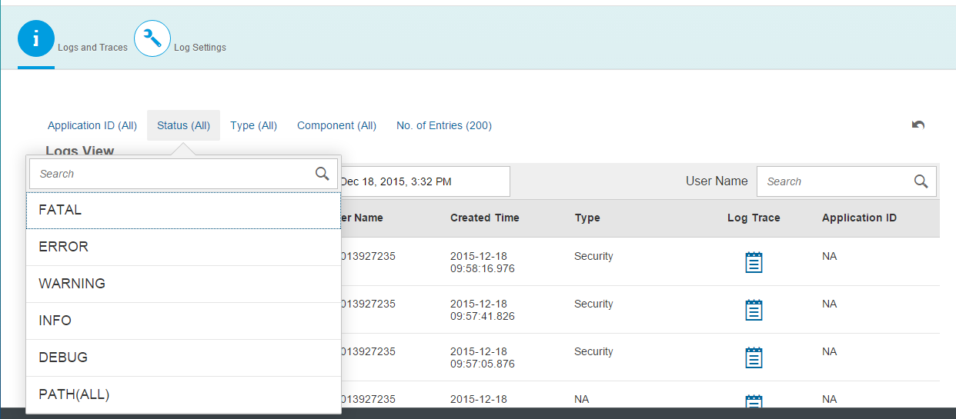

HANA Cloud Connector

View Logs on HANA Cloud Connector

In Hana Cloud Connector, navigate to Audit tab to view all the communication related to mobile application services and backend calls.
This information can be filtered based on timestamp or type of error information etc…

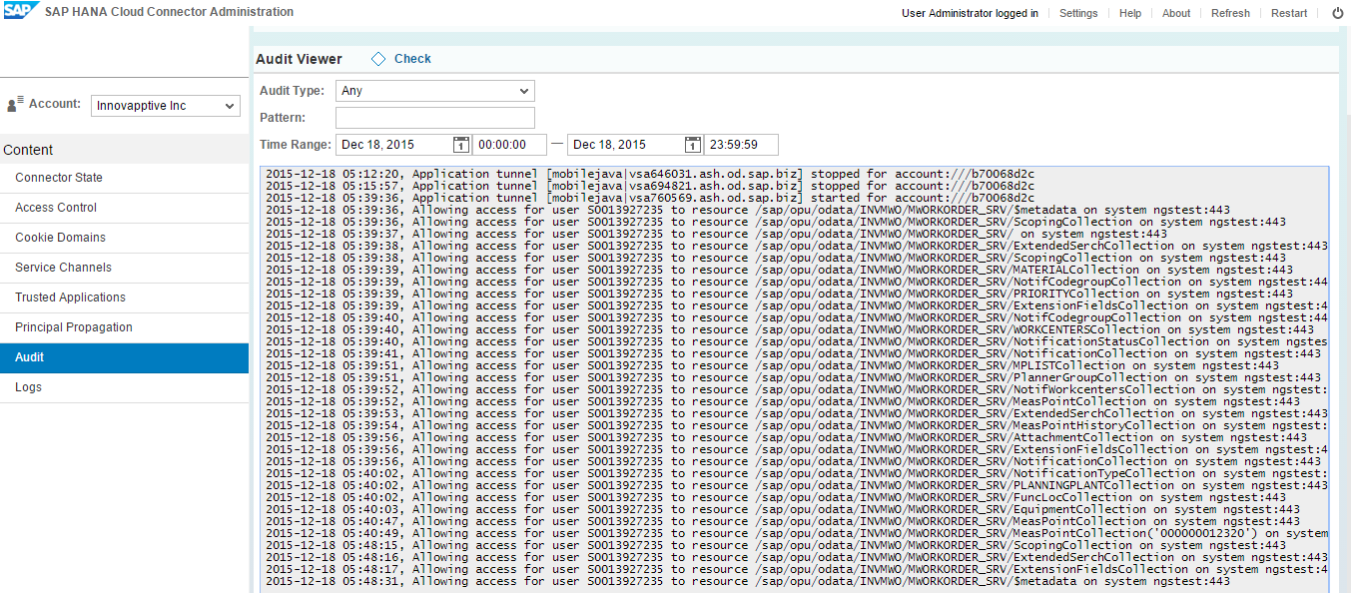

Navigate to ‘Logs’ tab to view any information related to HCC Admin tracing or any connection/Communication failures.
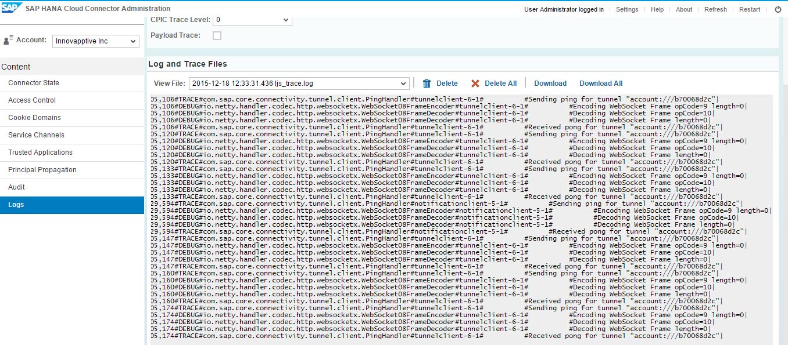

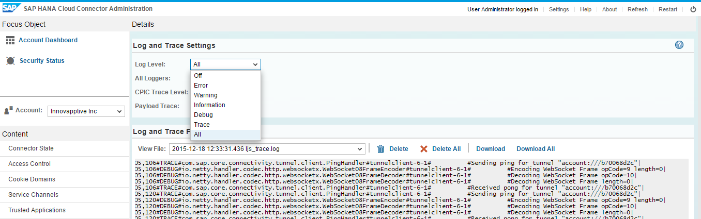

Old log files can be access from View File option, by selecting the log file based on timestamp.

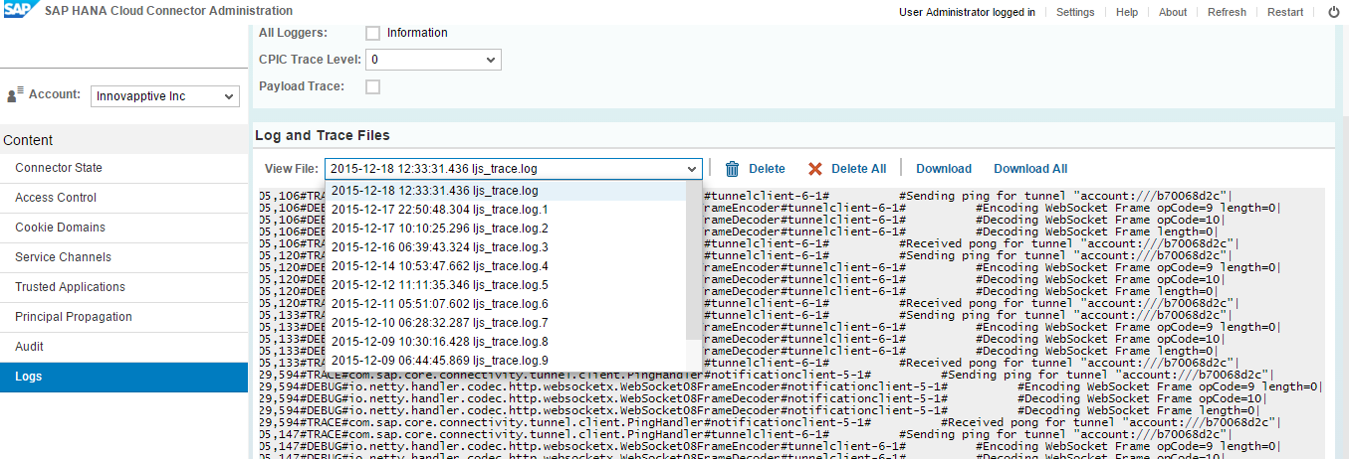

Device Logs

View Logs on Android Device

STEPS TO VIEW THE LOG FILE IN THE ANDROID DEVICE.

- Install ES File Explorer Application from the Google Play Store.

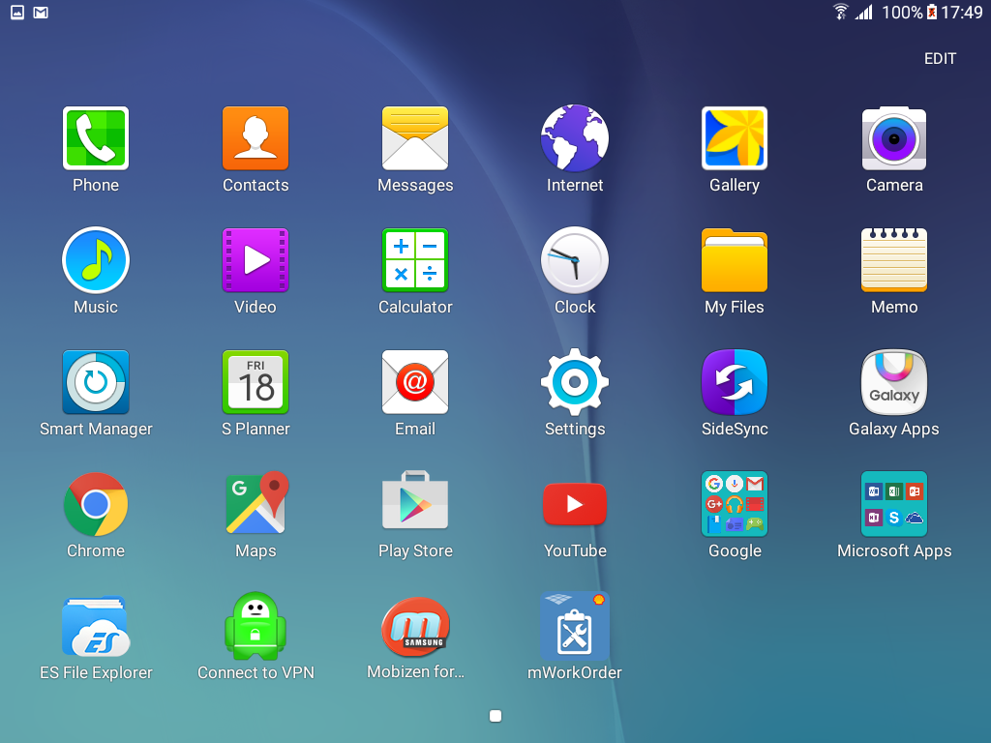

- Open on the ES File Explorer Application and click on the row with name SD.

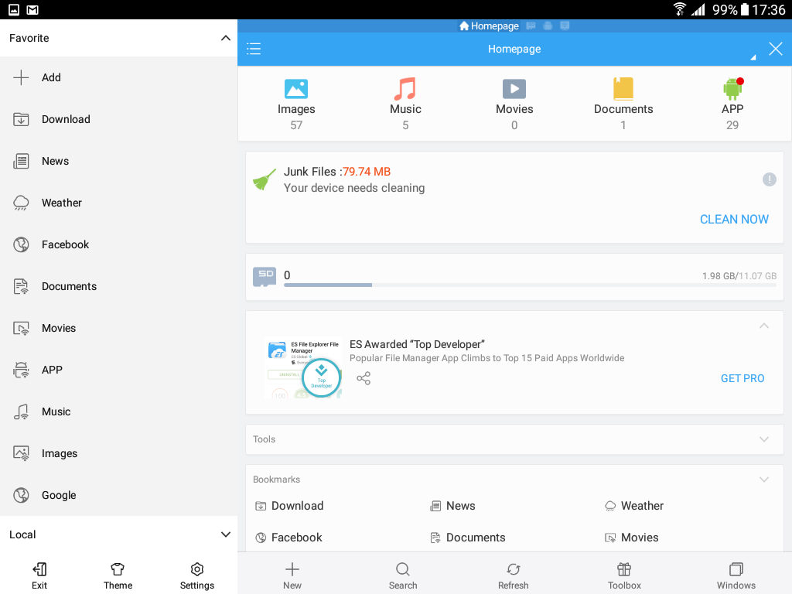

- Click on the folder with name mWorkOrder.

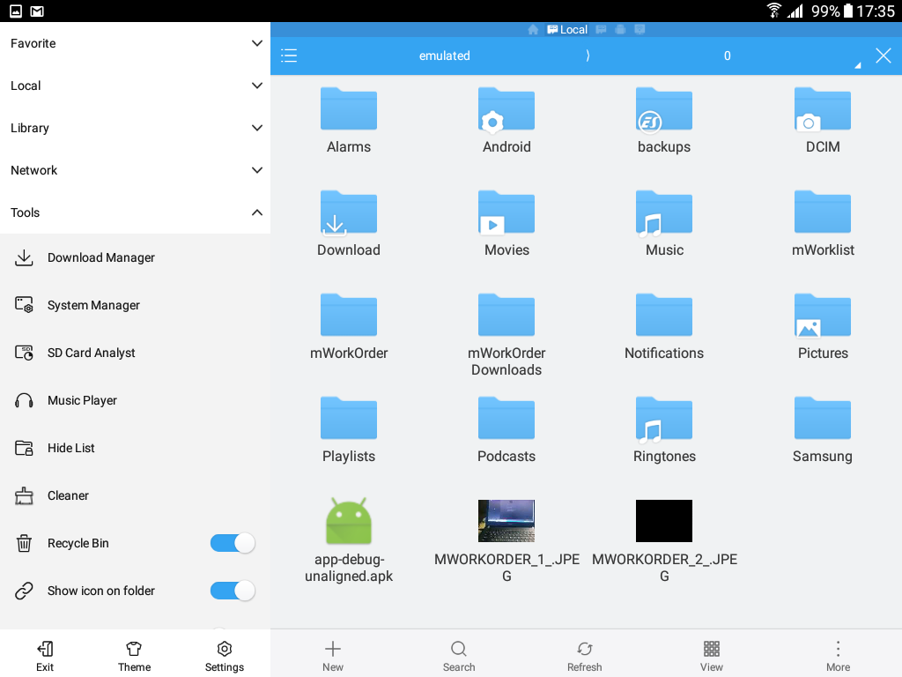

- After Opening the mWorOrder folder you will observe the .txt file in the following
format “mWorkOrder_Log_currentDate_24hrTimeFormat”.

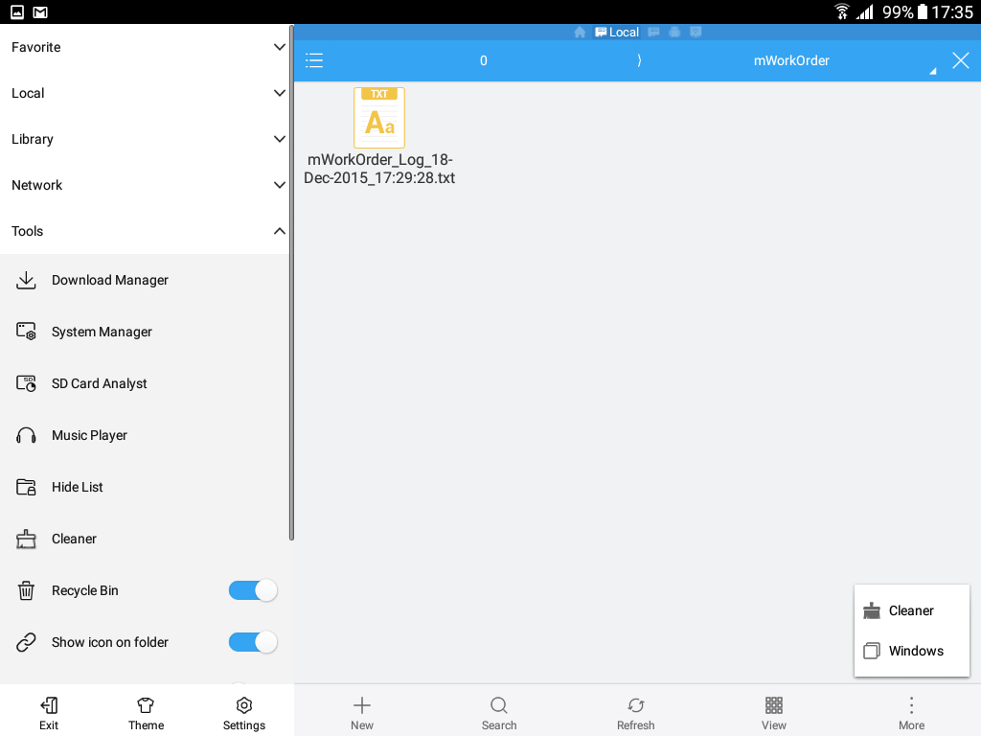

View Logs on IOS Device

To capture log files from iOS devices, we can use the attached iosconsole application. Below are the steps to capture application logs on device.
· We need a MAC system to capture this information. Download iosconsole from mac store.
· On MAC system, run the zip file to install the application.
· Connect device to the system and open the application 'iOS Console' before downloading the application.
· Download the application and launch it to reproduce the issue, and iOS Console will start capturing the application logs from the device and display on the console.

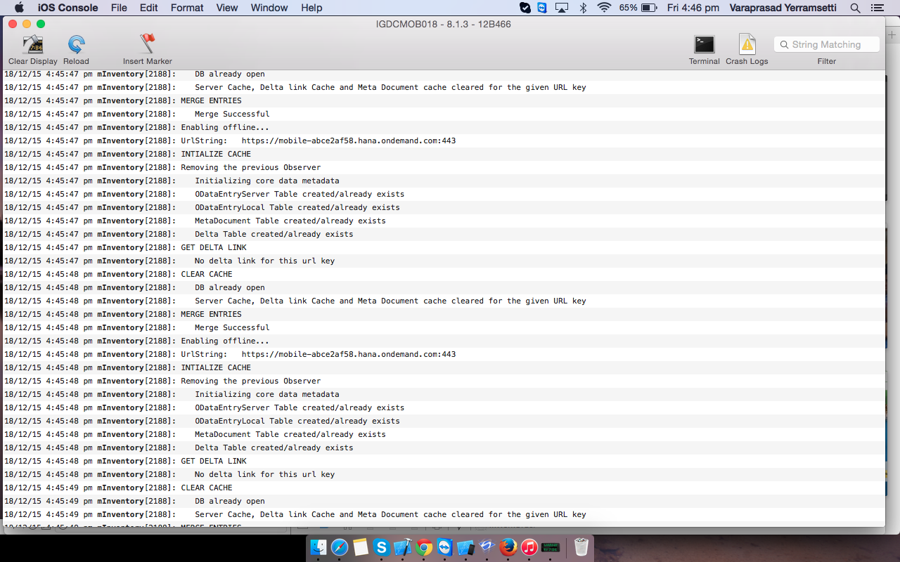

Error Logs in Backend
Open the Error Log (transaction: /iwfnd/error_log):

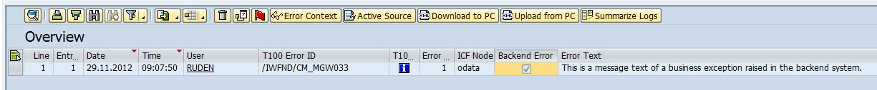

You can see a short error description in the Error Text field. For further information / functionality, click one of the following buttons.
Select the line with the error you are interested in and choose Error Context (marked black), Active Source (orange) or Download to PC/Upload from PC (blue).
If the error occurred in the SAP Business Suite backend system, select the Backend Error checkbox. For more information about how to handle such errors, see below.
Active Source:
The Active Source button enables you to navigate directly to the source code where the error occurred and the exception rose.
Error Context:
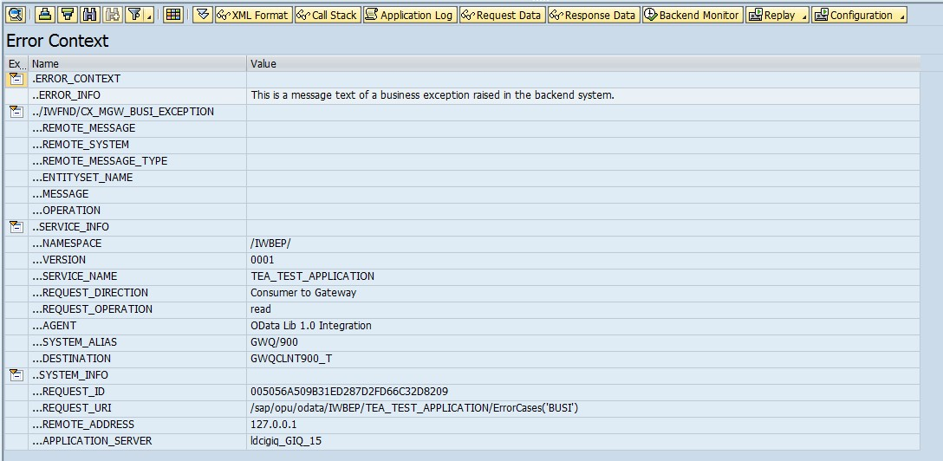

The Error Context provides detailed information about the error that occurred.
- Error_Info: shows a description of the error
- Namespace: shows the namespace in which the error occurred. It is important to ascertain whether the error occurred in the SAP Business Suite backend system or in the SAP NetWeaver Gateway hub system.
- System_Alias: shows the system and client in which the error occurred
Performance Trace
Tcode : /n/IWFND/TRACES

Right Click on Users & Request URI Prefix
Add user
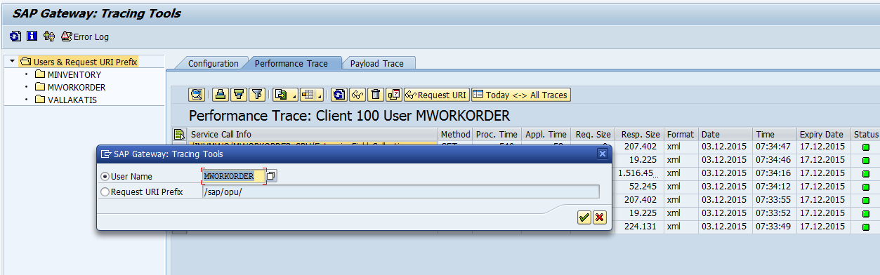
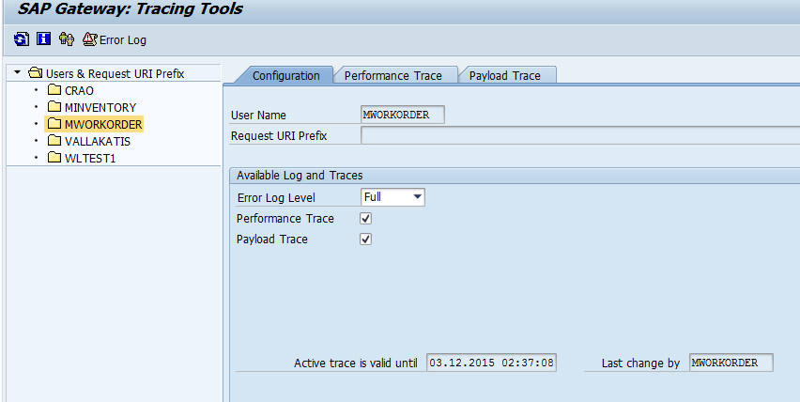
- Choose the Performance Trace tab to obtain a tabular overview of each service.

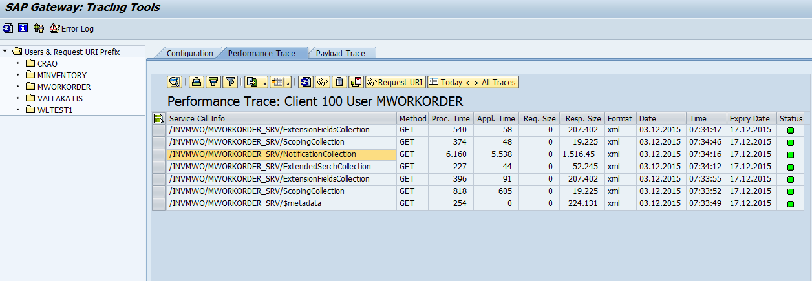

Double click on the specific service to check trace details.

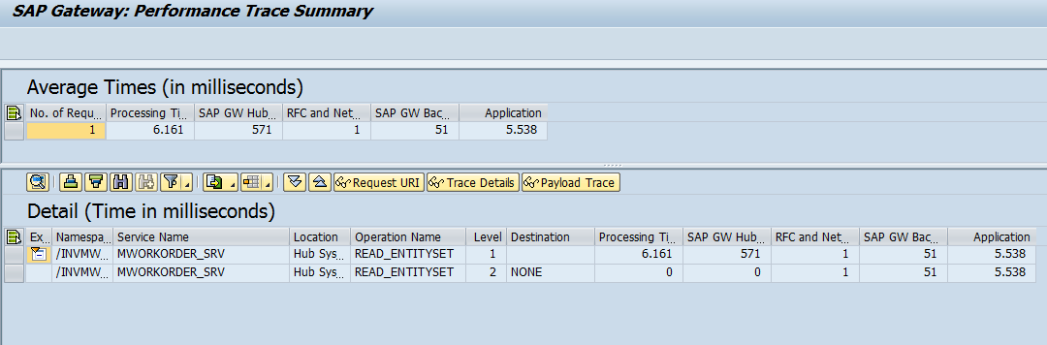
- Click on Trace details for:
Service call info
HTTP method (for example, POST or GET)
Processing time (in milliseconds)
Application time (in milliseconds)
Request size (in bytes)
Response size (in bytes)
Response format (xml, xlsx, json)
Status

